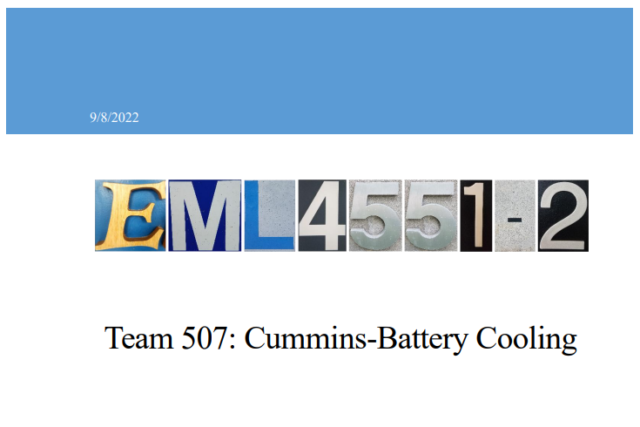

1.2 Customer Needs
Team 507 is working on designing a method to improve cooling in Lithium-Ion batteries in Hybrid vehicles by 5% over current industry benchmarks. Our sponsor for this project is Cummins and they will also serve as our customer for the project since we are designing our project for their use. We asked our point of contact at Cummins questions to develop our customer needs and recorded his responses. These responses were then interpreted into customer needs that we will use to guide our design.

Question | Customer Statement | Interpreted Need
- Should we be expected to design below the module level of the battery? | A scaled model of battery pack using pouch cells can be made with heating packs as a heat source. | The cooling design has the ability to be applied within the battery modules.
- What is the biggest risk of failure for a battery or pouch cells? | The biggest risks to battery pouch cells are thermal runaway then puncture. | Cooling design lowers risk of thermal runaway while avoiding puncture to pouch cells.
- Is there a limit to additional weight we can add to the battery pack? | The enclosure can weigh 20% of the module, 80% of the mass of the module should be the cells. | Design components other than pouch cells are less than 20% of weight of the battery module.
- Can we rearrange or redesign the layout of the modules? | We are designing the module, so yes. | The cooling design implements rearrangement or redesigning of the module configuration to improve cooling.
- Do we need to consider extreme outside temperatures that a battery could be subject to? | Consider ambient temperatures between –40 C to 40 C. Transmission tunnels can get up to 105 C and the outside frame rails can get to 85 C. | Cooling design performs effectively in extreme temperatures that would cause damage to the battery.
- Should our design be implementable into all types of vehicles? | Focus on heavy duty North American Class 8 vehicles. | The cooling design has ability to be implemented to North American Class 8 hybrid vehicle battery packs.
- Should our design be focused on both steady state and transient conditions during battery usage? | Yes, consider transient conditions. Reject heat up to C rates of 10. | Cooling design has the ability to withstand high rates of heat transfer during transient conditions.
- Do we need to incorporate our design into the battery’s Battery Management System? | Only incorporate the temperature probes from the battery’s Battery Management System. | Cooling design detects cell temperature and communicates with the Battery Management System.
- Are we able to incorporate pumps and heat exchangers into the design? | The domain of the project is the enclosure of the battery pack, however if pumps are used be sure to minimize the pressure losses. | A cooling design using pumps or heat exchangers minimizes pressure losses.
Table 1: Customer Needs
Customer needs questions were gathered prior to the meeting based on the project scope we had previously discussed with the customer. Before asking the customer our questions, we revisited the project scope and asked the sponsor if everything was accurate based on our first meeting. This helped us to narrow down what questions needed to be asked and which ones had already been answered and clarified. We then began asking the customer needs questions one at a time. The questions and the customer’s answers were recorded verbatim and then we made sure that we fully understood the customer’s response before moving forward to a new question.
The customer clarified that testing a model of the battery module would be satisfactory since testing an actual battery module would present unnecessary safety risks. We narrowed down the performance needs the customer desired as well. The customer clarified that the cooling method would need to work for C rates or discharge rates up to 10 and that ambient temperatures would need to be considered in a range of –40 to 40 degrees Celsius. We also clarified what safety risks the customer wanted us to consider. The main risks would be excessive heat and battery cell puncture. We clarified that the scope of our design is the inside of the battery module. However, outside pumps and heat exchangers could be considered and may serve as an effective method for battery cooling. The only outside integration with the Battery Management System that will be considered is the temperature probes integration with the BMS.

